Arc 4
- Town things
- Journey the temple
  - Begun leading into the jungle
  - Divergent path created months ago
    - Trees clearly infected and sick
    - Lead to a foul clearing
    - D lives in a trea
  - the party returns to the road there another path is burned into the ground
    - the path burns through the woods and as our heros progress down the path we see that the woods have begun to return to swamp, the water is thiner and dirt becomes muck becomes mud becomes a a shallow yet broad pond. Trees support themselves almost as stilts thought these trees are different, these trees look rotten and fallow, now that you notice it the water itself looks truly foul, dc 15 will allow you to decern dead looking creatures
- Temple to kalreg
  - Why is this here: during Kalreg’s former rule temples were constructed around the land to worship him as well as provide him military power. In the years after kalreg was defeated many of these temples were completely destroyed and rid of any surviving allies to the monstrous fiend
  - Architecture and vibe:
    - No windows and or sources of natural light, only a bizarre red haze the party cant quite understand
    - Walls made of a black porous, brittle, and strong brickworl
  - Room to room design
    - Entrance
      - The trap door
      - The puzzle
        - A statue of a human man with a sword in its sheath and arms at his side, looking directly at the ground with his feet shackled to the floor directly across from a large statue of a spire reaching to the sky. The spire is made of a black porous material almost coral esq with a opal gem at its peak
          - Dc 13 investigation: gems in the humans eyes match the opal in the spire, the building around them has cracks strewn about it
          - Dc 16 investigation: a thin almost imperceptible line runs along the neck of the statue, scuff marks on the floor just in front of the statue
          - Dc 20 investigation: there are joints along the knees waist, arms and neck. Marks on the shoulders
          - Solution: Pressing down on his shoulders animates the statue to move to the ground on his knees prostrating himself, drawing his sword across his throat moves his head back until the statue is staring at the gem in the spire.
    - Commons
  - Dread mechanic
    - Those inflicted with dread are under the thrawl of the war priest saieh and are subservient to their will.
    - There exists 3 levels of spite, each level exhibits the traits of the one before it
      - Level one
        - Damage for those resisting saieh’s influence: those who choose to give in must make all attacks recklessly
      - Level two
        - Hostility
      - Level three
        - Transformation
    - Shell of the water
      - Within 5 ft Those with dread instilled dc 15 wisdom to resist spite nullification
      - Within 10 ft all effects are nullified for those unafflicted.
      - Within 20 ft dc 10 wisdom to resist hostility and transformation, 1 d4 necrotic
      - Within 40 ft dc 15 wisdom, 1 d4 necrotic
      - Beyond 40 instant change
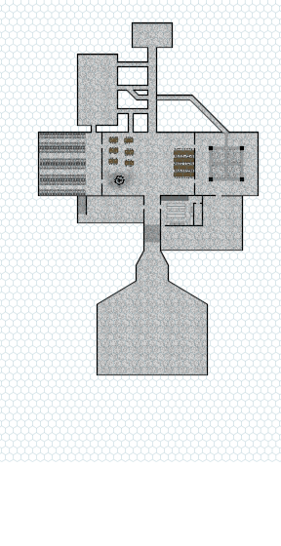
  - Dungeon layout
i
ii
iv
v
iii
vi
vii
viii
    - Entrance
    - Waste room
      - Laknfk
      - enemies
    - Sleep area
      - 400 pieces of Kalreg’s currency
    - Living room
    - Training area
    - Officers sleeping area
      - A row of small chambers
      - Officers procedural journal
        - Last entry: Weve been marked, their hammers clang on the outside
    - storage
    - Boss
      - Spite lv 2 in boss room
      - Enemies
        - 1 mummy lord adapted
          - Lower health
          - Lower damage ranged attack
          - Vulnerability to radiant
          - Resistant to fire
        - 2 skeletons adapted
          - Lower health
          - Shield charge attack
          - +1 skeleton every round
- Post dungeon
  - Escalation:
    - Better understanding of the tomb as a former and possibly future military base
      - Office containing a report of an officer pre, drums in the deep style
      - War priest spirit confronts you

Town rejects them for consorting with demons

